Professional Indemnity Insurance Explained

* Financial loss, injury or damage to any third party arising from a mistake or failure by the professional to exercise the required level of skill or expertise.
* A faulty design that results in financial loss or injury to a third party. E.g. a member designs a garden and the retaining wall collapses due to a fault in the design. The collapse in the retaining wall causes injury to a third party
* An horticultural assessment report that fails to identify a problem that has arisen or could arise from plant health issues, soil erosion, drainage issues or deterioration of hardscape works, the problem then causing Financial loss, injury or damage to any third party
* Unintentional infringement on another's copyright for their work, or to publish a passage forgetting to attribute the author, that later brings claims of infringement of copyright.

**©**AIH ‘What is PI’ v5_14

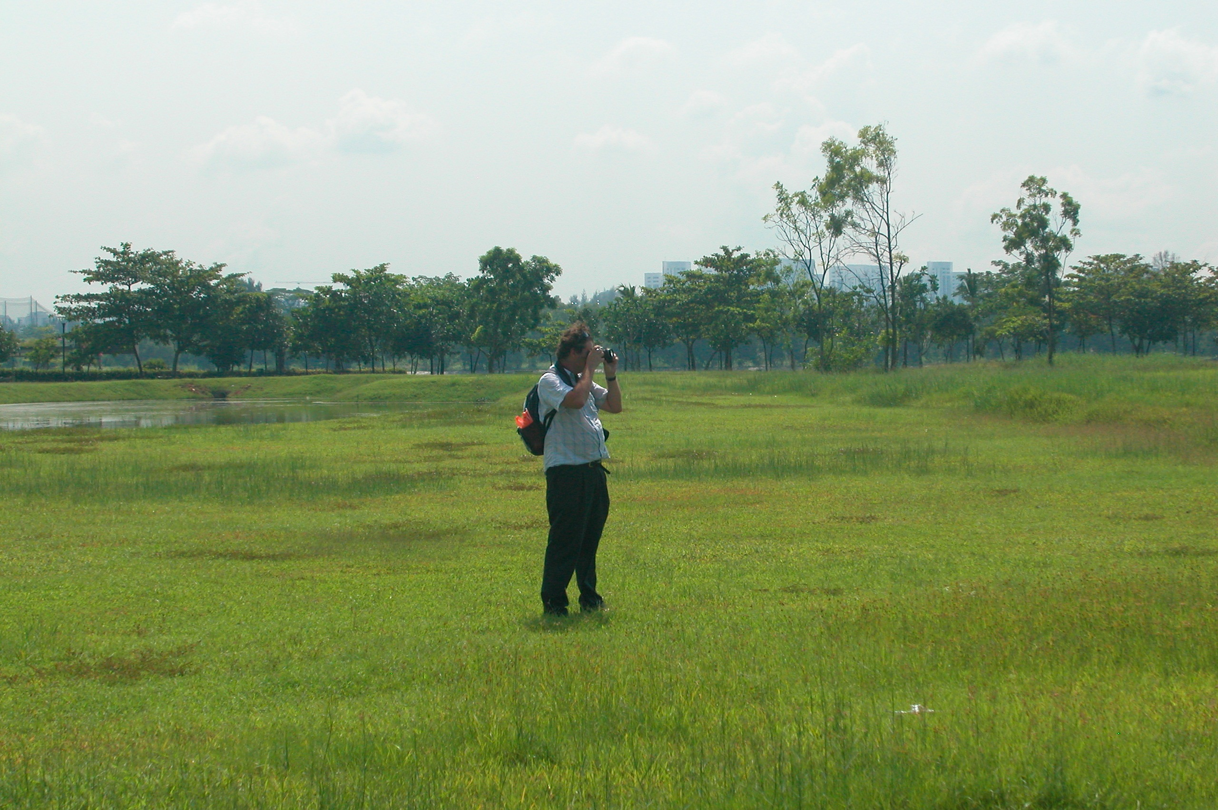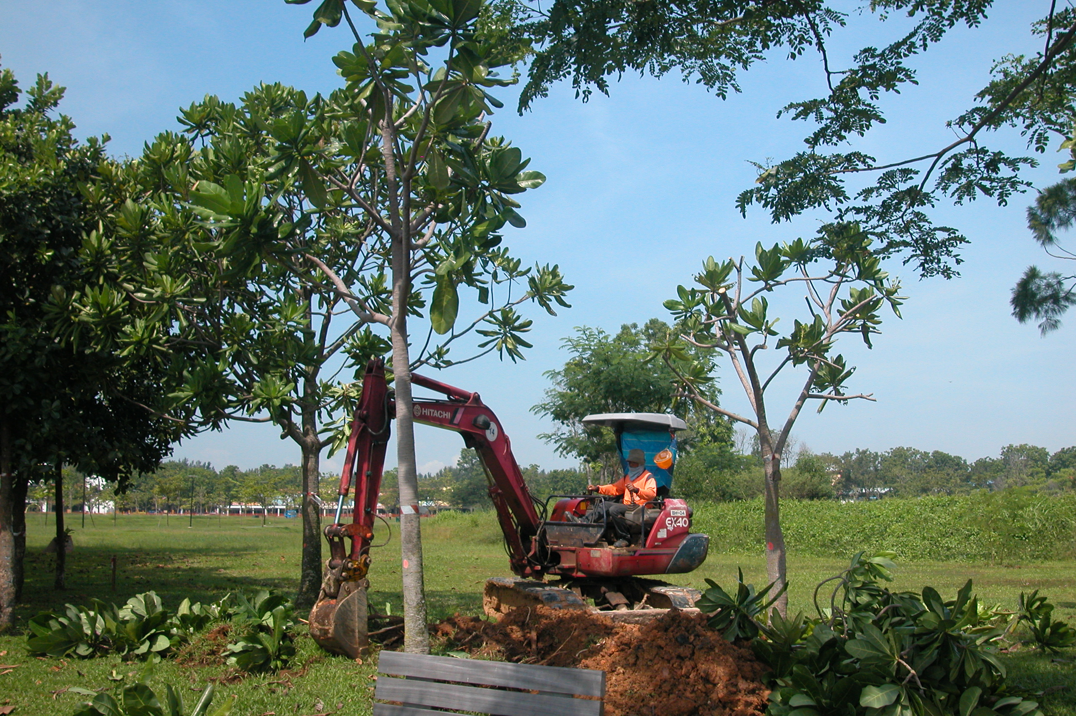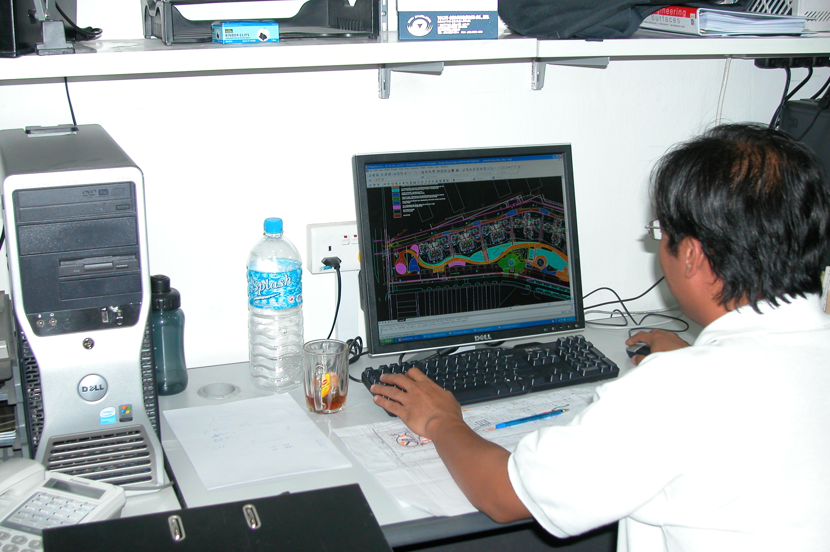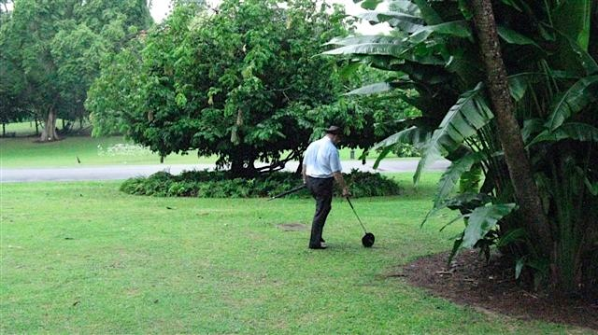

**Preferred Supplier Services**

**The AIH Group Insurance**

**Public and Products Liability**

The package offered by Fitzpatrick includes Errors & Omissions as an additional benefit. However for members who provide “advice for a fee” i.e. Design, plant species selection advice, maintenance program advisory services, health and assessment reports etc.; you are required to hold a separate Professional Indemnity Insurance Policy.

**For further information contact:**

Daniel Holmes,

Fitzpatrick & Co. Insurance Brokers P/L

Email [danielh@fitzpatrick.com.au](mailto:danielh@fitzpatrick.com.au)

Telephone: 03 8544 1636 Fax: 03 8544 1699

*Many of us believe that our business is too small to be concerned about its practices, and that we will never be negligent with our clients.*

*We like to think that we make good choices choosing our employees and their skills for which they are employed.*

*For a number of reasons most negligence cases are met with looks of disbelief when a summons is received.*

*To best ensure this risk is covered it is recommended to include Professional Indemnity Insurance as part of your business practice.*

***Examples of liability of professional advice***

## AIH Group Insurance Scheme

PO BOX 2238

Toowong, QLD 4066

email: info@aih.org.au  
[www.aih.org.au](http://www.aih.org.au)

Tel Answering Service: 02 8001 6198

Australian Institute of Horticulture Inc.

# What is Professional Indemnity Insurance?

***What is a Statute of Limitations?***

It is a period of time/limitation for bringing legal action. As claims can arise some time after the event you may have to keep your PI insurance current for several years. Generally the statute of limitations in Australia, for our area of work, is less than seven years. For certain construction related issues this may be up to 12 years. All instances are dependent on the relevant effective legislation.

***Registered Horticulturist (RH)***

AIH require all registering to hold PI insurance or show proof of coverage by employer.

***What do you do for a living?***

Do you own or manage a business or entity? Are you considered the professional expert in the field or your skills? As a manager, or lead consultant, are you the expert in the entity to which you are contracted? Are you expected to advise your clients and in return you want their ongoing custom?

***Does it affect Employees and Contractors?***

Does your employer hold PI insurance to cover your provision of expertise and skills? Is liability and indemnity mentioned in your employment contract?

Employees may be found to have shown gross neglect and dereliction of duties and not be personally covered by their employers PI.

What will you do then?

***What does a PI insurance policy cover?***

PI Insurance provides cover for Members in respect of claims arising from wrongful advice.

The Insurer pays to defend your position & reputation, and pays out against a loss, so you are covered for any potential compensation in the event of losing a claim.

Frequently Asked Questions

Anyone that takes a fee for service and delivers a product that a client relies upon is a candidate for PI insurance.

Contractor, sub-contractor, business owner, senior manager - occasionally there are situations that arise where a client may hold you liable for advice you have given that has caused the client financial loss.

PI insurance protects you, your company; and mostly, but not always, your contractors, sub-contractors and your employees; against these instances.

***Who is a Professional with regard to insurance?***

A professional is someone with a tertiary qualification (denoting education beyond school, especially at college or university level) who provides advice for a fee.

***When are you not covered?***

Many PI claims may come some time after you have provided the service to the client. As PI policies expire when they are cancelled you may not be covered if the claim is made after that date even though you may have sold the business, changed careers or retired. The timeframe is dependent upon the state and commonwealth statutes of limitation.