Australian Institute of Horticulture Inc
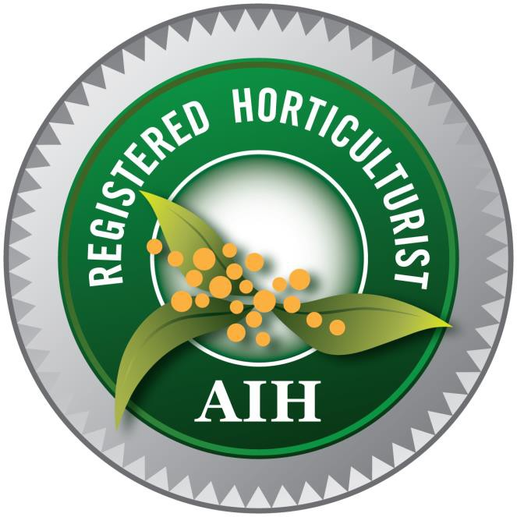

Registered Horticulturist Log Book

Name:

RH Accreditation Number: RH Date of Initial Registration:

About this log book  This logbook has been developed to assist Registered Horticulturists in monitoring their compliance with their continuing professional development (CPD) requirements and in creating a CPD portfolio. This logbook may be printed and submitted if requested as part of an audit or compliance process.  The information below should be read in conjunction with the standards and guidelines published by the Australian Institute of Horticulture available www.aih.org.au/publications |  | Completing this form  - Read and complete all questions  - Type directly into the table using Acrobat Pro  - OR Print out and Use a black or blue pen only  - Print clearly in BLOCK LETTERS  - Please complete ALL boxes
RH Accreditation number - RH0 | Membership Number
Full Name | Residential Address
Date of Birth | Site/Building and/or Position/Department (if applicable)
Contact Phone | Address
Mobile | City or Suburb
Email | State |  | Postcode
Company/Business Name ( if Applicable) | Country
Declaration
I confirm that all the information I have provided in this form and supporting documents is true and correct to the best of my knowledge
Signature |  |  | Date

What are the Specific Requirements to Maintain Registration?  The Institute's requirements in relation to CPD are set out in its RH accreditation policy and its guidelines for CPD, published at www.aih.org.au/publications  The Institute expects Registered Horticulturists to be familiar with and meet the CPD requirements as set out in those documents.  Under the policy, as an Registered Horticulturists you must:  - Gain a total of 24 CPD points over a two year period to maintain your registration.  - Maintain your Professional Indemnity insurance.  - Attend three AIH Workshops or seminars or other approved industry events in the first two year period following registration.  - Attend, subscribe or take part in other related AIH approved activities.  - Carry-over any points above the 24 CPD points in any one 2 year reporting period to the following period.  - Maintain this Logbook of your CPD activities.  - Make available this Logbook that it may be audited by AIH at any time with 30 days notice.  - Pay an annual RH accreditation fee each membership renewal date.  Planning Your Learning Activities for your CPD Biennial Program  CPD undertaken by Horticulturists should be consistent with the ethics and principals set out in the various policies and codes published by the Institute. In planning your schedule of activities each two year period you should consider and record information that addresses your needs:  - What learning have you identified to meet your future professional needs?  - Will the activity meet your learning need?  - Will the activity contribute to the maintenance and development of your competencies and practices?  - Will the activity provide better outcomes for your clients?  - Will the activity contribute to meeting your Social, Environmental, Economic and Cultural accountability? Refer to the AIH brochure ‘Building a Movement’.  - What opportunities or motivation for further education or learning could the activity create for you? | What are CPD Activities?  Refer to page 4 for further information  Learning occurs through a wide variety of formal and informal activities.  To support an RH program AIH have implemented a CPD Continuing Professional Development calendar of workshops, events and activities.  Other industry events will also be recognised by AIH.  It is recommended that these activities contribute to your CPD plan.  Formal learning activities are activities that contribute to the maintenance and development of competencies and practices  Formal learning activities may refer to:  - Tertiary and other accredited courses.  - Distance education competencies and online learning (should include an examination or assessment component)  - Undertaking research and presentation of work (for example papers for publication, major conference posters, and official submissions).  - Making horticultural related presentations (for example research presentations, poster presentations, lectures, seminar presentations).  Informal and incidental learning CPD activities may refer to:  - Attendances at conferences, forums, seminars and workshops.  - Self-study through reference materials, journals, subscriptions etc.  - Case discussion with other professionals/colleagues  - Attendance at field trips, study tours, involvement in horticultural media events  - Industry representation  - Quality assurance activities such as practice accreditation  - Informal Research  - Supervision and or mentoring of apprentices, students or new or young practitioners.  - Peer review groups  Types of Evidence (including but not limited to):  - Receipts  - Overview of event  - Brochure  - Enrolment  - Statement of Attainment or Qualification Certificate  - Photographs / graphics

 | TABLE OF POINTS: CPD Activities and How to Accumulate Points |  |  | KEEPING YOUR BIENNIAL CPD RECORDS AND  MANAGEMENT
 | Description of Activity | Hours (excl meals and travel) | Notes | - Members are to keep their own records of their CPD activities – for tracking and audit by AIH.  - AIH Workshop attendees will be recorded in the AIH Continuing Professional Development Workshop records held by the AIH Administration.  - Proof of attendance and workshop overview must be provided.  - Proof of current Professional Indemnity Insurance or equiv.
1. | AIH – CPD workshops and programmed events as per AIH calendar | 3 points for ½ day workshop; 6 points for full day workshop | Additional 1 point per hour if the presenter
2. | AIH-endorsed conferences, seminars, workshops | 0.5 points per hour of active attendance | Maximum 6 points per event
3. | Attendance at Regional meetings | 1 point
4. | Walk and Talk events | 1 point
5. | Other industry relevant conferences, seminars, workshops. AIH representation on industry committees | 0.5 points per hour for approved events | Maximum 3 points per event
6. | Representation at approved industry events – signed off by regional convenor | 0.5 points per hour of active involvement | Maximum 6 points per event
7. | Field trips, open days, product launches | 0.5 points per hour | Maximum of 3 points per 24 month period | CATEGORIES TO BE RECOGNISED:
8. | Special consultancies and projects that extend professional knowledge | 3 points per activity | Maximum of 6 points per 24 month period | The following Continuing Professional Development (CPD) categories will be considered suitable for continuing RH accreditation:
9. | Courses leading to formal qualifications or competencies | 12 points for full qualification Cert IV and above | One qualification within any 24 month period of registration | A. Horticultural Science Units of plants, soil, water and integrated plant & landscape health.
10. | Achievement of individual competencies achieved through recognised approved training provider or other formally assessed learning outcomes from other institutions | 2 points per competency | Maximum of 6 points within any 24 month period of registration | B. Technical Practice - sector specific skills including landscape construction & design, parks, gardens, nursery, turf management, production, irrigation, drainage;
 | Description of Activity | Hours (excl meals and travel) | Notes
11. | Supervised research and published papers | 6 points per project. 3 points per published paper | Maximum of 12 points within any 24 month period of registration | C. Social, Environmental, Economic & Cultural Accountability – Carbon farming/ sequestration, Environment and Natural Resource Management, Urban & Regional Green Space Planning, Health & Safety.
12. | Conference paper with report to AIH Journal | 4 points |  | D. Other relevant areas – as approved by AIH.
13. | Contribution of accepted articles to an approved journal | 0.5 points | Maximum of 6 points within any 24 month period of registration
14. | Proof of subscription to appropriate journals, magazines | 0.5 points per relevant subscription | Maximum of 3 points within any 24 month period of registration
15. | National Council Meeting | 0.5 points
16. | Service as Regional Convenor | 3 points per year of service
17. | Specific mentoring | 1 point per annum per mentoree
18. | AIH Conference | 4 points
19. | AIH Dinner | 1.5 points
20. | AIH Conference Tour | 1.5 points

CPD log book Two Year Period – From: _ _/_ _ / _ _ To: _ _/_ _ / _ _
Name and Description of Activity | Date | Hours | Points | Organising Group | Evidence Provided
1. AIH – CPD workshops and programmed events as per AIH calendar
Please attach a neat addendum for this section, if required
2. AIH-endorsed conferences, seminars, workshops
3. Attendance at Regional meetings
 | Points Sub-Total |  |  | Verified & Initialled by Registrar

CPD log book Two Year Period – From: _ _/_ _ / _ _ To: _ _/_ _ / _ _
Name and Description of Activity | Date | Hours | Points | Organising Group | Evidence Provided
4. Walk and Talk events
5. Other industry relevant conferences, seminars, workshops. AIH representation on industry committees
6. Representation at approved industry events – signed off by regional convenor
 | Points Sub-Total |  |  | Verified & Initialled by Registrar

CPD log book Two Year Period – From: _ _/_ _ / _ _ To: _ _/_ _ / _ _
Name and Description of Activity | Date | Hours | Points | Organising Group | Evidence Provided
7. Field trips, open days, product launches
8. Special consultancies and projects that extend professional knowledge
9. Courses leading to formal qualifications or competencies
10. Achievement of individual competencies achieved through recognised approved training provider or other formally assessed learning outcomes from other institutions
 | Points Sub-Total |  |  | Verified & Initialled by Registrar
Name and Description of Activity | Date | Hours | Points | Organising Group | Evidence Provided
11. Supervised research and published papers
12. Conference paper with report to AIH Journal
13. Contribution of accepted articles to an approved journal
14. Proof of subscription to appropriate journals, magazines
15. National Council Meeting
 | Points Sub-Total |  |  | Verified & Initialled by Registrar
Name and Description of Activity | Date | Hours | Points | Organising Group | Evidence Provided
16. Service as Regional Convenor
17. Specific mentoring
18. AIH Conference
19. AIH Dinner
20. AIH Conference Tour
 | Points Sub-Total |  |  | Verified & Initialled by Registrar
Name and Description of Activity | Date | Hours | Points | Organising Group | Evidence Provided
21. Other
 | Points Sub-Total |  |  | Verified & Initialled by Registrar
Grand Total of all Pages |  |  |  | DATE VERIFIED

NOTES

